

FACULTY OF INFORMATION AND COMMUNICATION TECHNOLOGY
PROG 101:PROGRAMMING LANGUAGE

Title :Designing Logical Solutions for Sierra Leone Community Challenges
Issue Date : Week 2
Due Date : Week 4
Lecturer/Examiner : Mr. Elijah
Name of Student : KELVIN MATTHEW YOVONIE
Student ID No. : 905006111
Class : B.I.T. 1101
Semester/Year : 1/1

Academic Honesty Policy Statement

I/We, hereby attest those contents of this attachment are my own work. Referenced works, articles, art, programs, papers or parts thereof are acknowledged at the end of this paper. This includes data excerpted from CD-ROMs, the Internet, other private networks, and other people’s disk of the computer system.

Student’s Signature: Date: 5th October 2026
LECTURER’S COMMMENTS/GRADE:

for office use only upon receive
Remark

DATE :
TIME :
RECEIVER’S NAME :

Abstract

Okada (commercial motorcycle taxi) parks are one of the most common ways of travelling in Sierra Leonean towns and communities, yet many operate without a fair, recorded or safe way of requesting and allocating rides. Passengers compete informally for riders, disputes arise over turns, vulnerable passengers such as women, the elderly and children are disadvantaged, and riders may be pressured to carry more passengers than is safe. This report presents the Okada Park Ride Queue System (OPRQS), a logical design that addresses this problem without writing a computer program, as the assignment requires.

The system welcomes the passenger, records the destination and the number of passengers, and repeats a validation loop until the request is complete and sensible. It then issues the next consecutive queue number and checks whether an okada is ready and whether the group is within the limit of four passengers. The passenger is told that the ride is either assigned or kept in the queue, and the last queue number and a safety message are displayed.

The solution is developed through computational thinking, step-by-step algorithms, pseudocode and Flowgorithm flowcharts. The core design is then extended into a modular design with constants, functions, Boolean logic and a repeat loop that serves many passengers in one run. Its correctness is checked with truth tables, ten test cases, a trace table and sample scenarios with expected outputs. The design supports SDG 11 (sustainable cities and communities), SDG 3 (good health and well-being, through road safety) and SDG 8 (decent work). It is also argued to be suitable as open source software and a Digital Public Good, because it is free to use, transparent, adaptable to local needs and stores no personal data. Its long-term sustainability rests on its simplicity, its low cost and the possibility of community maintenance by local students and volunteers.

Introduction

Reliable transport is essential for reaching markets, schools, workplaces and health services. In many Sierra Leonean towns and communities, where roads are narrow and public buses are infrequent, much of that transport is provided informally by okada (motorcycle taxi) riders working from local parks. This arrangement keeps transport affordable and gives many young people a livelihood. However, it also leaves the process of requesting and allocating rides to personal negotiation. Passengers are often served by whoever shouts first or stands closest, no record exists of who arrived first, and no rule checks the size of a group before a ride is given. The results are disputes over turns, unfair treatment of women, the elderly and children, lost time for riders, and unsafe practices such as overloaded motorcycles.

The assignment asks for a logical solution to a community challenge, not a finished program. This matters because good software begins with good logic: a problem must be analysed, broken into smaller parts and expressed as clear, ordered steps before any code is written, since errors are much cheaper to correct at the design stage (Farrell, 2018). This report therefore applies the four pillars of computational thinking, namely decomposition, pattern recognition, abstraction and algorithm design (Wing, 2006), to the okada park problem. The result is the Okada Park Ride Queue System (OPRQS), which records a passenger's request, validates it, issues a queue number and decides whether a ride can be assigned immediately or must wait.

The design was built and traced in Flowgorithm (Cook, n.d.), a flowchart tool that can run a flowchart step by step and display the same logic as pseudocode and Python. Using these views side by side allowed the flowchart, pseudocode and executable logic to be checked against one another for consistency. The student's core design is then extended into a modular design with constants, functions and a repeat loop, so that it demonstrates every programming logic concept the assignment requires.

Beyond the logic itself, the report considers the wider purpose of the solution. It explains how OPRQS supports the Sustainable Development Goals (United Nations, 2015), why it should be released as open source software (Open Source Initiative, n.d.), and how it could qualify as a Digital Public Good (Digital Public Goods Alliance, n.d.) that any community can adopt freely and safely.

The report follows the structure required by the assignment. Section 1 gives the rationale, covering the problem, its background, its community impact and the SDG, open source and Digital Public Good justifications. Section 2 sets out the step-by-step algorithm and Section 3 the pseudocode. Section 4 presents the flowcharts, and Section 5 describes the functional modules, variables, constants and Boolean logic. Section 6 demonstrates the expected outputs through sample scenarios, test cases and a trace table. Section 7 records the GitHub evidence, and Section 8 lists the references.

Rationale

Problem Description

Okada (commercial motorcycle taxi) parks are one of the most common ways people move around towns and communities in Sierra Leone, especially where roads are narrow and buses are infrequent. In many parks, however, passengers are served informally: whoever shouts first or stands closest gets the next rider. No record exists of who arrived first, where each person is going or how many people want to travel together. This design addresses one practical problem: the absence of a fair, recorded and safe way to request and allocate rides at an okada park.

Who is affected? Passengers lose time and face disputes over turns. Women, elderly people, children and people carrying luggage are often least able to compete for a rider. Okada riders lose earnings to arguments and unclear demand, and may be pressured to carry more passengers than is safe. Park leaders spend time settling quarrels, and other road users are put at risk by overloaded motorcycles. [Insert one verified local statistic on okada use or road traffic injuries here and cite it in Harvard style]

Why does the problem exist? Requests are made by shouting or gestures. Nothing validates a request (for example, a missing destination or an impossible number of passengers). There are no queue numbers, so order cannot be proved, and no rule checks group size before a ride is assigned. Passengers are also not told whether they have been assigned a rider or must wait.

How does the proposed solution address it? The Okada Park Ride Queue System (OPRQS) greets the passenger, records the destination and number of passengers, and rejects incomplete or impossible requests until they are corrected. It then issues a queue number and checks whether an okada is ready and whether the group size is within the allowed limit of four passengers. It tells the passenger either "Assigned queue" or "Kept in queue", then displays the last queue number issued and a safety message.

Background

Motorcycle taxis, known locally as okada, have become one of the most widely used forms of public transport across West Africa. They can reach places that buses and cars cannot, they are quick to find, and they are affordable for many passengers. For many young people they are also a source of income that requires little capital to enter. In Sierra Leone, riders commonly work from parks or stations, and these are often organised by local leaders or rider associations that settle disputes and keep order.

This informal organisation has real strengths, but it also has limits. Because requests are made by shouting, gestures or personal arrangement, there is no shared record of who asked first, where each passenger is going or how many people are travelling together. Disputes over turns are therefore settled by argument or by influence rather than by a rule that everyone can see. The people least able to compete, such as women, the elderly, children and passengers with luggage, often wait longest. Riders may also feel pressure to accept more passengers than a motorcycle can carry safely in order not to lose a fare. These problems are logical as much as technical. Nothing in the process checks that a request is complete, counts requests in order or tests whether a group is within a safe limit.

Problems of this kind are well suited to computational thinking. They can be broken into small parts, they follow repeated patterns, and they can be solved with clear rules. Before any software is written, a sound logical design is essential, because errors in logic are much cheaper to correct on paper than in a finished program (Farrell, 2018). Wing (2006) describes computational thinking as a way of solving problems by drawing on concepts from computer science, which is the approach followed here.

For that reason, this solution was first designed and traced using Flowgorithm, a free flowchart tool that executes a flowchart step by step and can display the same logic as pseudocode and Python (Cook, n.d.). Using these views side by side allowed the algorithm, flowchart and pseudocode to be checked against each other for consistency. The result is a design that a park association could understand, test and adapt, because it uses only simple input, decisions and repetition and does not depend on expensive equipment or a permanent internet connection.

Community Impact

The problem being solved is the lack of a fair, recorded and safe way to request and allocate rides at an okada park. OPRQS replaces shouting and personal influence with a simple rule that everyone can see: each valid request receives the next queue number, and requests are served in that order.

Expected impact. Passengers know straight away whether a ride is assigned or whether they are waiting, and what their position is. Disputes over turns are reduced because the queue number is proof of arrival order. Vulnerable passengers, such as women, the elderly, children and people carrying luggage, no longer have to compete physically for a rider. Riders spend less time arguing and can see demand clearly, which helps them plan their work. The group-size rule supports safer practice because a ride is not assigned to a group larger than the limit. Park leaders gain a simple record: the last queue number tells them how many requests were handled in a session.

Beneficiaries. The direct beneficiaries are passengers, okada riders and park associations. Indirect beneficiaries are local councils, which gain more orderly transport, other road users, who are safer when motorcycles are not overloaded, and the wider community, which gains a more reliable and trusted transport service.

Long-term sustainability. The solution is sustainable because it is simple and cheap. It uses only basic input, decisions and repetition, so it needs no paid software, no special hardware and no permanent internet connection. A park secretary can learn to run it after a short briefing. Its rules are held in clearly named constants, so the association can change the passenger limit without rewriting the logic. Because the design is open and documented, student developers and local volunteers can maintain it, translate it into Krio or extend it, for example with a text-message version. Over time the same approach can be reused for other transport points such as kekeh and taxi parks.

Proposed Solution

The proposed solution is the Okada Park Ride Queue System (OPRQS), a menu-free, step-by-step system that handles one passenger request after another. It has two layers.

The core design is the student's Flowgorithm solution. It displays a welcome message, sets queueNumber to 0 and reads the destination and the number of passengers. A WHILE loop then rejects any request in which the number of passengers is 0 or less, or the destination is empty, and asks for both values again until the request is valid. The system then increases queueNumber by 1 and reads whether an okada is ready. An IF decision uses AND to test two conditions together: the answer must be "Yes", and the group must be four passengers or fewer. If both are true the passenger sees "Assigned queue" with the number, and otherwise "Kept in queue" with the number. The system finishes by displaying the last queue number and a safety message.

The modular design keeps exactly the same logic but organises it so that it is easier to test, reuse and change. The limit of four passengers is held in the constant MAX_PASSENGERS. Six functions each return one value: GetDestination, GetPassengers, Is ValidRequest, tQueueNumber, IsYes and CanAssign. Three modules handle the output messages: DisplayWelcome, DisplayResult and DisplayClosing. A repeat loop, controlled by the variable more that the core design had declared but not used, allows one run to serve many passengers in a row. IsYes also accepts "yes", "Yes" or "YES", so a simple typing difference does not wrongly keep a passenger in the queue.

As the assignment requires, only the logical design is presented, through algorithms, pseudocode and flowcharts. The Python view in the report was generated automatically by Flowgorithm and is used only to verify that the flowchart, pseudocode and expected outputs agree (Cook, n.d.).

Computational Thinking Process

The design follows the four pillars of computational thinking described by Wing (2006):

•Decomposition: the park process is broken into welcome, capture request, validate request, issue queue number, check okada readiness and group size, report result, and closing message. In the modular design each becomes a module or function.

•Pattern recognition: every passenger follows the same pattern of entering details, correcting mistakes, receiving a number and waiting for an assignment decision. This is why validation is a loop and why the whole process can be repeated for the next passenger.

•Abstraction: details that do not affect queue decisions (fare, rider name, route, motorcycle number) are ignored. Only destination, passengers, queue number and okada readiness are modelled.

•Algorithm design: the remaining steps are placed in an ordered, unambiguous sequence using sequence, selection (IF) and repetition (WHILE).

ALGORITHM DESIGN

1. Start
2. Display the message "Welcome to Okada Park."

3. Display the message "You can request now for a ride."

4. Declare the variables: destination, okadaReady, more, passengers and queueNumber.

5. Initialize queueNumber to 0.

6. Display a message requesting the passenger to enter their destination.

7. Enter the destination.

8. Display a message requesting the number of passengers.
9. Enter the number of passengers.

10. Check whether the number of passengers is less than or equal to 0 OR the destination is empty.

11. IF the information is invalid, display a message saying "Please correct the request" and request the destination and number of passengers again. Return to Step 10.

12. ELSE, increase the queue number by 1.

13. Request the Okada availability status by asking whether an Okada is ready.
14. Enter the Okada availability response.

15. Check whether OkadaReady is equal to "Yes" AND the number of passengers is less than or equal to 4.

16. IF the condition is TRUE, display "Assigned queue" together with the queue number.

17. ELSE, display "Kept in queue" together with the queue number.

18. Display the last queue number.

19. Display the message "We wish you a safe ride."

20. END.

SUSTAINABLE DEVELOPMENT GOAL (SDG) ALIGNMENT

The proposed Okada Park Ride Request System aligns with Sustainable Development
Goal 11 (SDG 11): Sustainable Cities and Communities, established by the United Nations. SDG 11 aims to make cities and human settlements inclusive, safe, resilient and sustainable.
The system contributes to this goal by improving the organization and management of passenger transportation services. Through its computerized queue management process, passengers can submit ride requests, provide their destinations and indicate the number of people travelling. This helps reduce confusion, promotes fairness in passenger allocation and makes transportation services more organized.
The system also supports the following SDGs:
1. SDG 9 – Industry, Innovation and Infrastructure: It encourages the use of technology and logical programming to improve transportation management.

2. SDG 11 – Sustainable Cities and Communities: It promotes organized, accessible and efficient transportation services within the community.

3. SDG 3 – Good Health and Well-being: It supports passenger safety by considering the number of passengers assigned to each Okada.

4. SDG 8 – Decent Work and Economic Growth: It can help Okada riders manage their services more efficiently, potentially improving their daily economic activities.

In conclusion, the Okada Park Ride Request System demonstrates how simple computer programming and logical decision-making can contribute to sustainable community development. It provides an organized approach to transportation management while supporting safety, innovation and efficiency.

1. OPEN SOURCE
Open-source software refers to computer programs whose source code is freely available for users and developers to study, modify and improve. It allows developers to build and maintain applications without depending entirely on expensive commercial software.
The proposed Okada Park Ride Request System can be developed using open-source tools such as Python, Flowgorithm and MySQL. These tools can help developers design, test and manage the system at a lower cost.
Benefits of Open Source to the System
Low Cost: Reduces the cost of developing and maintaining the system.
Flexibility: Allows developers to modify and improve the system.
Transparency: Makes it easier to examine how the program operates.
Innovation: Encourages developers to introduce new features.
Maintenance: Makes it possible to identify and correct programming errors.

2. DIGITAL PUBLIC GOODS JURISDICTIONS
Digital public goods are digital resources, such as open-source software, open data and digital technologies, that can support sustainable development and benefit society.
The Okada Park Ride Request System can adopt digital public goods principles by promoting accessibility, transparency, privacy and responsible use of technology.
Important Areas of Consideration
Data Protection: Passengers' personal information should be collected and handled responsibly.
Privacy and Security: The system should protect passenger information against unauthorized access.
Accessibility: The system should be simple and easy for different users to operate.
Digital Inclusion: The system should consider people with limited digital skills or access to technology.
Responsible Technology: The system should be developed and used in a way that benefits the community.
Conclusion
Open-source software provides the tools and flexibility needed to develop the Okada Park Ride Request System, while digital public goods principles encourage accessibility, security and responsible technological development. Together, they can support an affordable and efficient transportation management solution.

PSUEDCODE

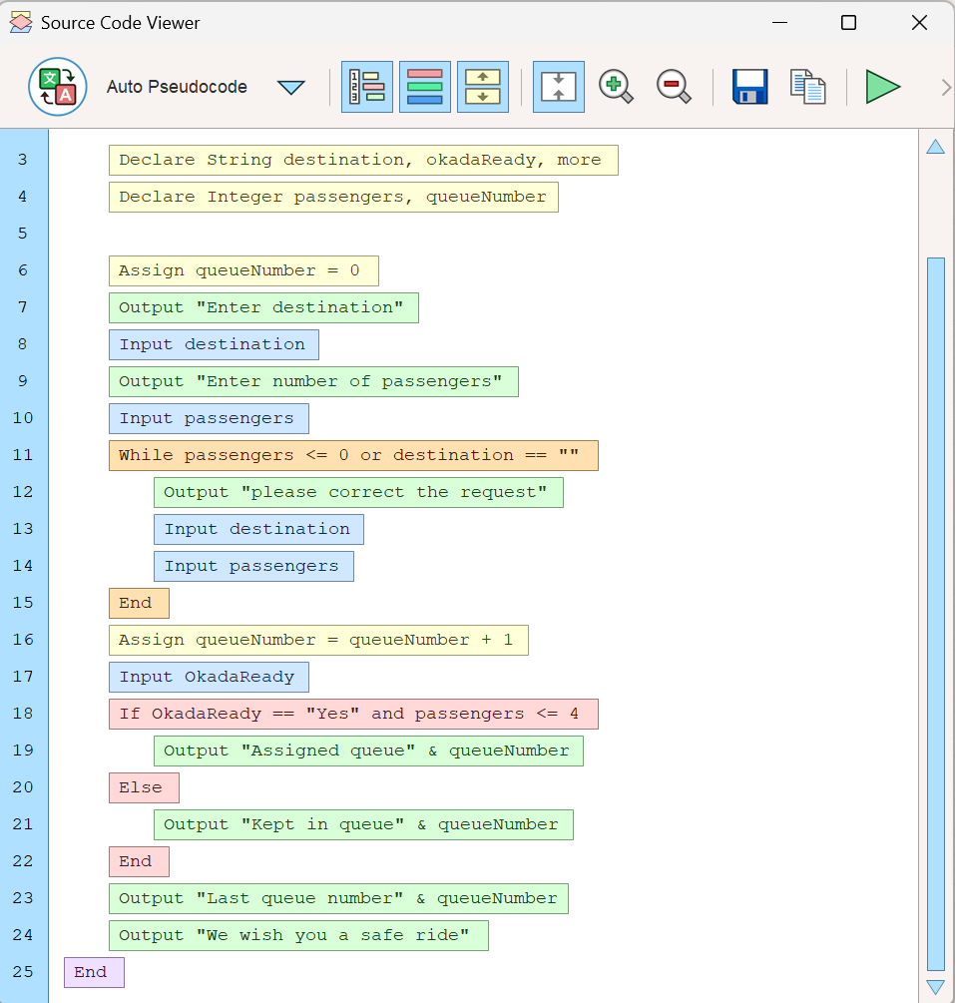

FLOWCHART

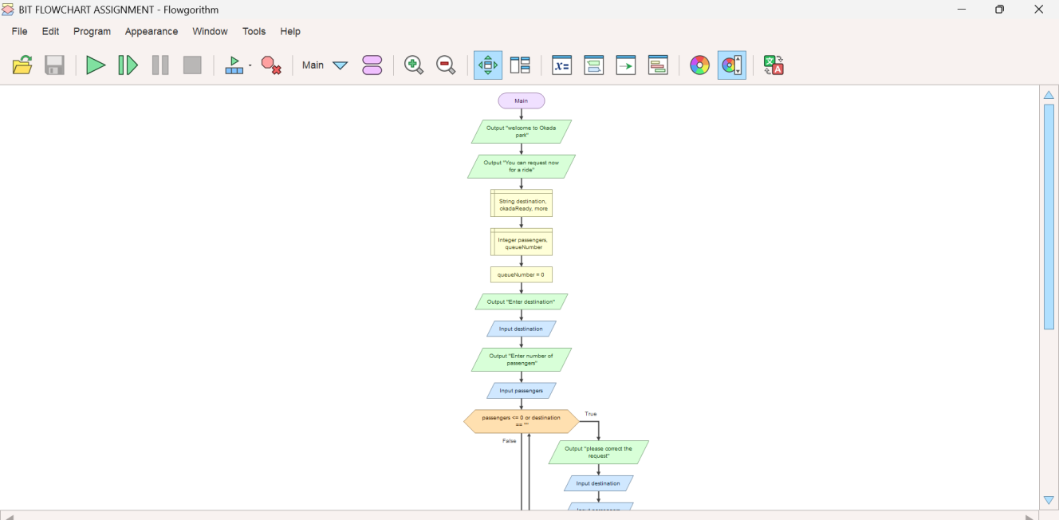

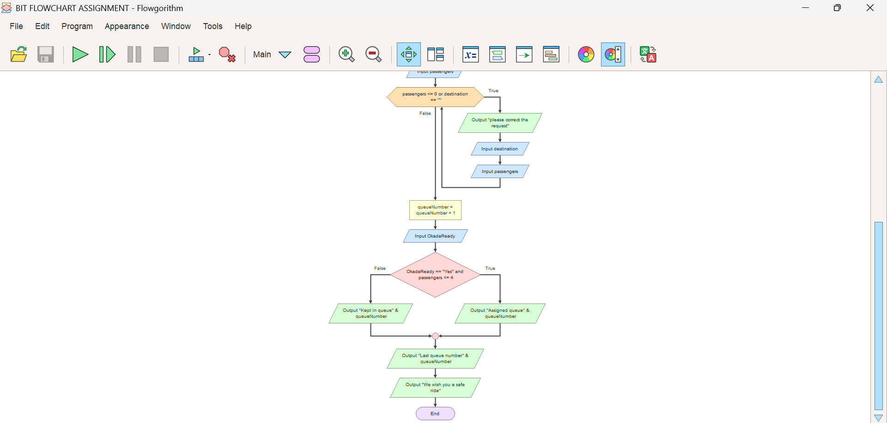

FUNCTIONAL MODULES OF THE OKADA TRANSPORTATION SYSTEM

The Okada Transportation System consists of several functional modules that work together to manage passenger requests, organize queues and improve transportation services. Each module performs a specific task to ensure that the system operates effectively and efficiently.

1. Passenger Registration Module
This module allows passengers to provide the necessary information required to request a ride. It collects details such as the passenger's destination and number of passengers.

2. Destination Management Module
This module allows passengers to enter their intended destinations. It helps the system identify where passengers want to travel.

3. Passenger Validation Module
This module checks whether the information entered by passengers is complete and valid. It ensures that the destination is not empty and that the number of passengers is greater than zero.

4. Queue Management Module
This module automatically generates queue numbers for passengers. It helps organize passengers according to their request order and reduces confusion at the Okada park.

5. Okada Availability Module
This module checks whether an Okada rider is available to transport passengers. It helps determine whether a passenger can be assigned a ride or kept waiting in the queue.

6. Passenger Allocation Module
This module assigns passengers to available Okada riders based on availability and the passenger limit. In this system, an Okada can be assigned when the number of passengers is four or fewer.

7. Notification Module
This module displays messages to passengers about their request status. It informs them whether they have been assigned a queue or kept waiting.

8. Queue Tracking Module
This module displays the latest queue number generated by the system. It helps passengers and park operators monitor the queue.

9. System Termination Module
This module ensures that the program ends after completing the ride-request process and displaying the final message to passengers.

EXPECTED OUTPUT OF THE OKADA TRANSPORTATION SYSTEM

The expected output of the Okada Transportation System is to provide an organized, efficient and reliable method of managing passenger ride requests at an Okada park. The system is designed to collect passenger information, validate requests, generate queue numbers and check the availability of Okada riders.
The expected outputs include the following:
Successful Passenger Registration: The system should accept passengers' destinations and the number of passengers travelling.

Input Validation: The system should identify incorrect or incomplete information and request the passenger to correct it.

Automatic Queue Number Generation: The system should generate a unique queue number for every valid ride request.

Okada Availability Status: The system should determine whether an Okada rider is available.

Passenger Allocation: The system should assign passengers to an available Okada when the conditions are satisfied.

Queue Notification: The system should inform passengers whether they have been assigned or kept in the queue.

Queue Tracking: The system should display the latest queue number to help monitor passenger requests.

Improved Transportation Management: The system should reduce confusion, promote fairness and improve the organization of transportation services.
Sample Expected Output

GITHUB

REFERENCE

